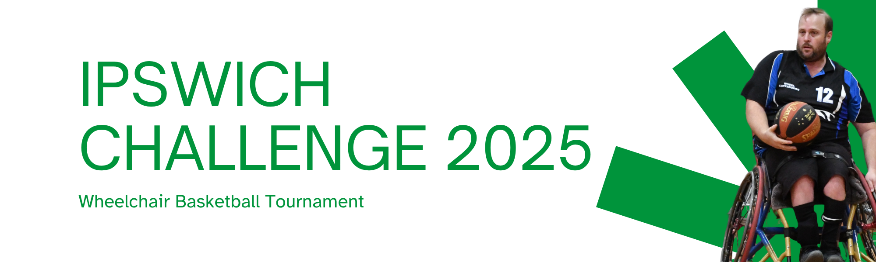

**Welcome to the Ipswich Challenge 2025!**

On behalf of Sporting Wheelies, we extend a warm welcome to all participants, volunteers, partners, and spectators to the Ipswich Challenge 2025 Wheelchair Basketball Tournament.

Sporting Wheelies is committed to providing inclusive sporting opportunities for all. We're thrilled to see so many of you here today, making this year's tournament our biggest yet by registrations! Thank you for your support.

We deeply appreciate the dedication of our volunteers, the support of our partners, and the enthusiasm of all the teams participating. Let the games begin!

|  |  |
| --- | --- |
| **Event Information** | |
| **Venue:** YMCA Springfield Central Community Centre 134A Parkland Dr, Springfield Central  The venue is accessible, with 6 accessible toilets on site.  **Access Notes**   * On Sunday, participants are asked to enter the Sports Hall via the left-hand side gate (Entry 2) if the Lighthouse Church group have already set up in the foyer. * Please limit use of the communal kitchen (Tea/Coffee Area) and foyer until after 11:30am on Sunday, once the church group has packed up.   The main Sports Hall will be open both days for competition, with plenty of seating available for athletes, volunteers, and spectators.    **Event times:** Venue will open at 7:30am both days.  **Presentations:** Sunday at 3:45pm (approx. 30 mins) | **Venue Map Highlights:**   * Main Court * Spectator Seating * Drop-off Zone * Accessible Parking * Toilets/Changerooms * Volunteer/Staff Check-in Desk   95367e18bb24021c2a8ced8b44661eb7.png  *Inside Venue Map:*  00bc6899ada591dfe04837bf887c3bea.png  Emergency Exits & Evacuation Map:  b97022cfd91ca62e7ea18509ea76975b.png |
| **Food & Catering** | |

* **Rotary Club Breakfast Service:** Available both mornings (Bacon and Egg Burgers)
* **Sausage Sizzle:** Enjoy a sausage sizzle both days.
* **Free Tea/Coffee:** Complimentary tea and coffee will be available.
* **Vending Machines:** For additional snacks and drinks.
* **BYO Food:** Feel free to bring your own food and refreshments. We have fridges on site (please label food).
* **Orion Springfield Central Shopping Centre:** A short drive away for more options.

|  |
| --- |
| **The Draw** |

*Day 1*

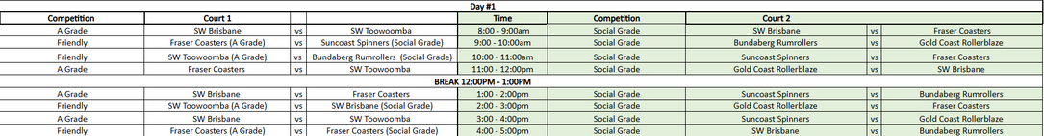

*Day 2*

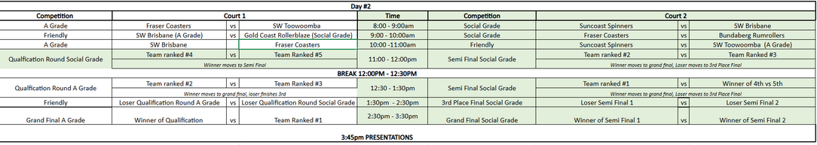

|  |
| --- |
| **Awards & Presentations** |

Join us for the awards presentation on Sunday to celebrate the achievements of our teams and individuals.

**Awards:**

* Team Awards (A Grade & Social Grade) | Champions, Runners up, 3rd Place
* Individual Awards (A Grade & Social Grade) | MVP & All Star 5
* Volunteer Recognition

|  |
| --- |
| **Event Partners & Acknowledgements** |

Sporting Wheelies extends our sincere gratitude to our event partners and supporters:

* YMCA Springfield Central Community Centre
* Dedicated Volunteers
* Referees
* Spinal Life Australia
* MP Jennifer Howard (Presentation)

Your support is essential to the success of the Ipswich Challenge 2025!

**Thank you for attending!**

**Event Hashtag:** #IpswichChallenge2025

**Event Page:**  
[Wheelchair Basketball - Ipswich Challenge 2025 - Sporting Wheelies](https://www.sportingwheelies.org.au/sports/wheelchair-basketball/wheelchair-basketball-ipswich-challenge-2025-2/)

